**GROUP 15 REPORT**

**INTRODUCTION**

This report introduces "Check To-Do," a to-do list and task collaborative tool for college students. This web application helps college students organize their tasks and collaborate with their peers. This program aims to boost college students' productivity and foster better teamwork and collaboration.

We believe Task collaborative software is becoming increasingly important for college students as it helps them to stay organized and manage their workload more efficiently. It allows them to collaborate with their peers, share resources, and keep track of deadlines. It also helps them to stay on top of their assignments and projects by providing reminders and notifications. With task collaborative software, college students can easily access all the information they need in one place, making it easier for them to stay on top of their studies.

**FUNCTIONAL REQUIREMENTS**

1. Account Management: The system provides the capability for students to create and maintain a personal account.

2. Task management: The system provides the capability for students to create, view, update, and delete tasks. This includes; viewing the status of a task, and checking the activity of collaborators and colleagues.

3. Notifications: The system notifies users when a task is due or uncompleted. It must also notify users of collaborators' activities.

4. Record Keeping: The system keeps a record of old tasks.

5. Integration with 3rd Party Systems: The system would be compatible with third-party systems like mailing and notification systems.

6. Motivational Content: The system would occasionally motivate students to finish tasks by displaying motivational quotes.

NON-FUNCTIONAL REQUIREMENTS.

1. Compatibility: Check To-Do is compatible with various browsers, operating systems, and devices.

2. Usability: The system is easy to use and understand with clear instructions and user interfaces.

3. Security: The software will meet certain security standards, such as encryption of sensitive data, protection against unauthorized access, and compliance with industry regulations.

**USE CASES**

There are two actors on Check To-Do, the student and the collaborator. The relationship between the student and the collaborator isn’t compulsory. It is only created after a collaborator is added to a task and the collaborator in question accepts the request to collaborate on said task. Until the collaborator accepts the request to collaborate on the task, the task won’t be active.

Below is a use case diagram to demonstrate the various use cases relating to Check To-Do.

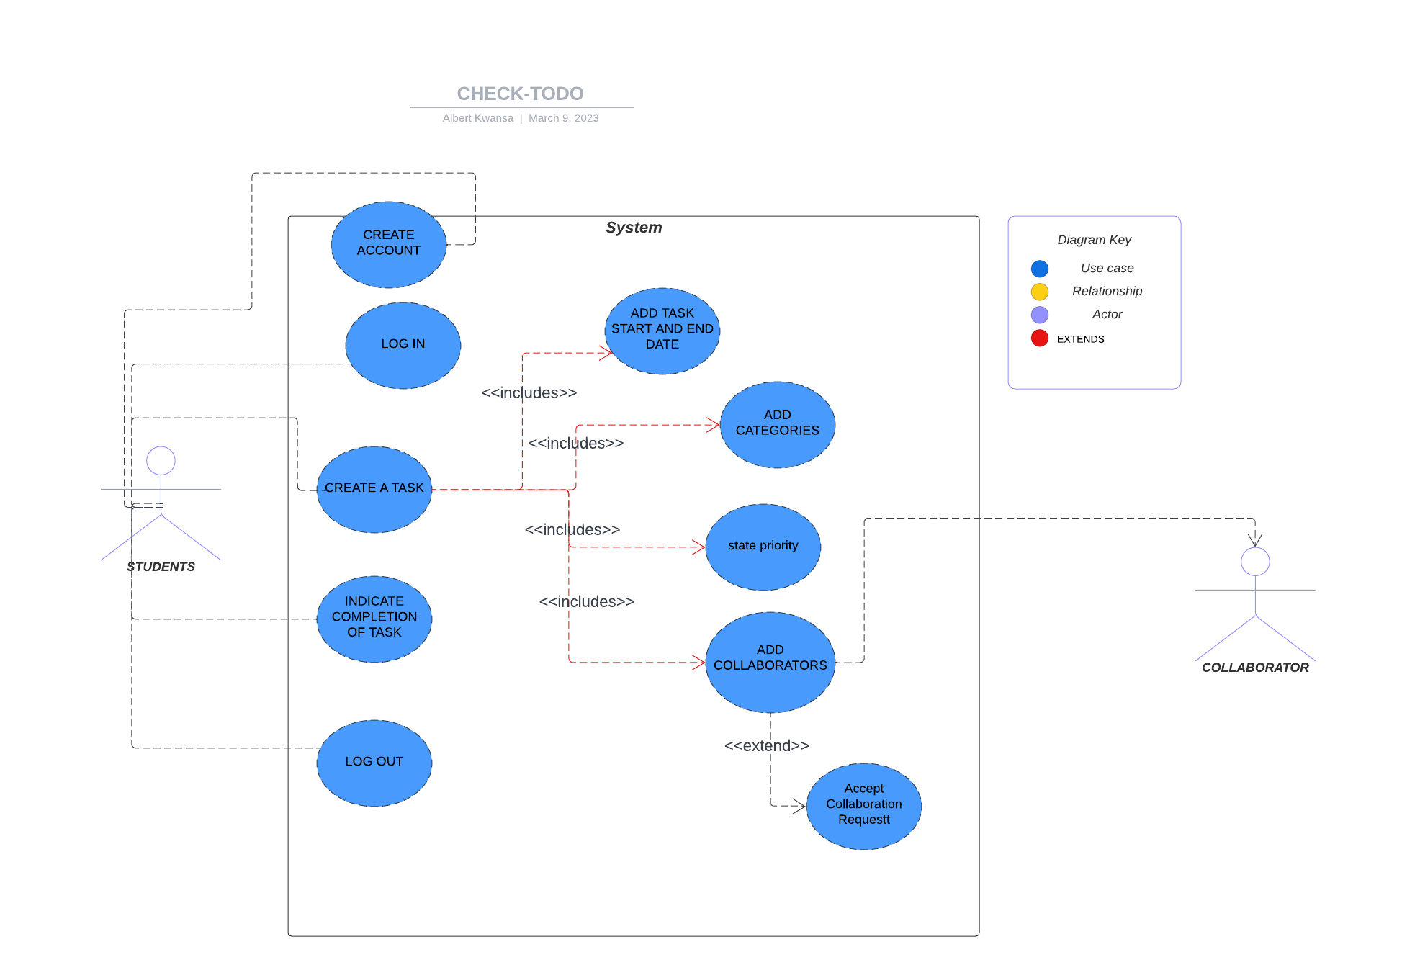

**SYSTEM ARCHITECTURE**

Check To-Do It runs on Firebase and PHP for the backend, while the UI is built with HTML, CSS, and JavaScript.

The Database was structured using this ER diagram as a guide.

This structure is subject to change depending on changing scenarios and requirements.

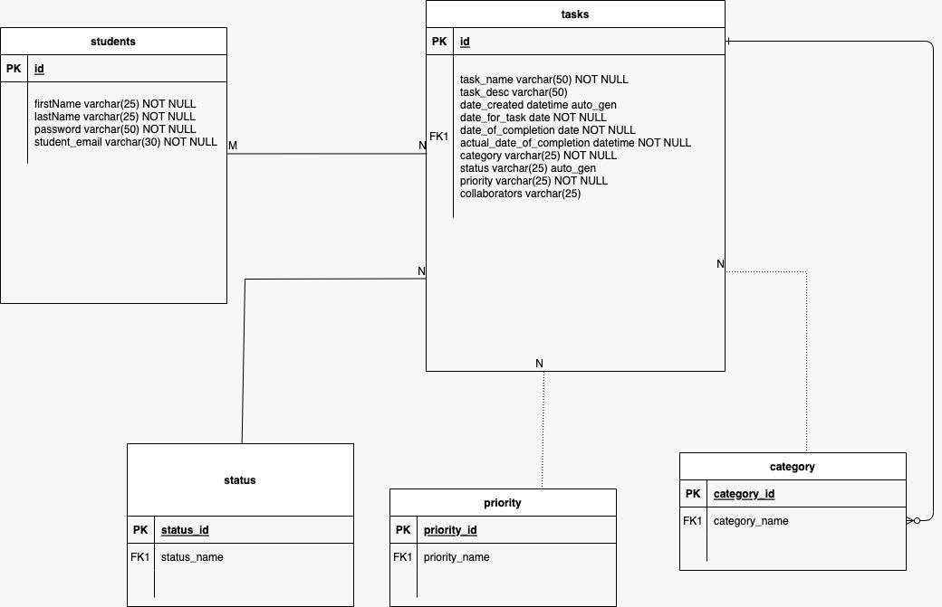

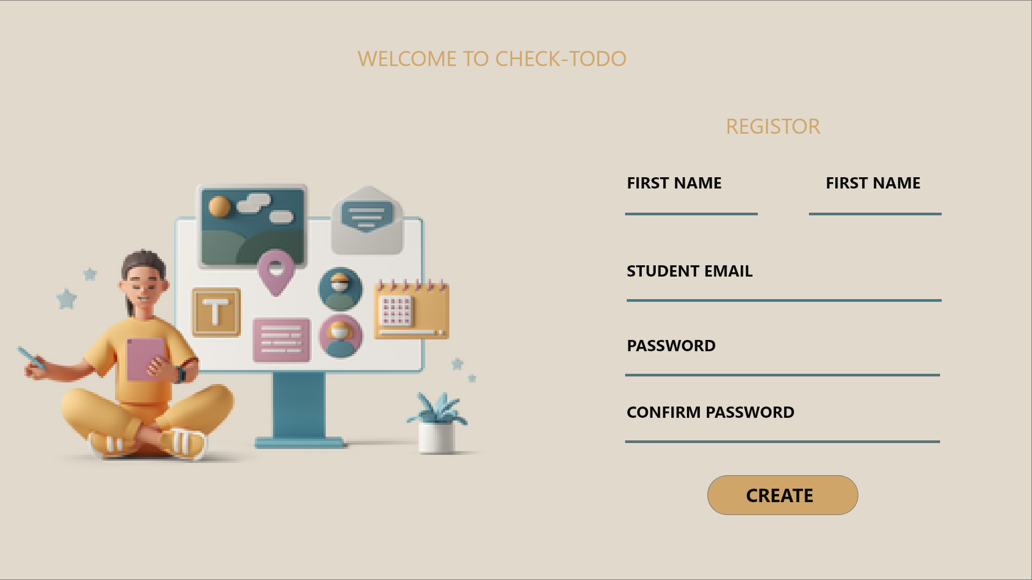

Check To-Do Sign Up form for Account creation.

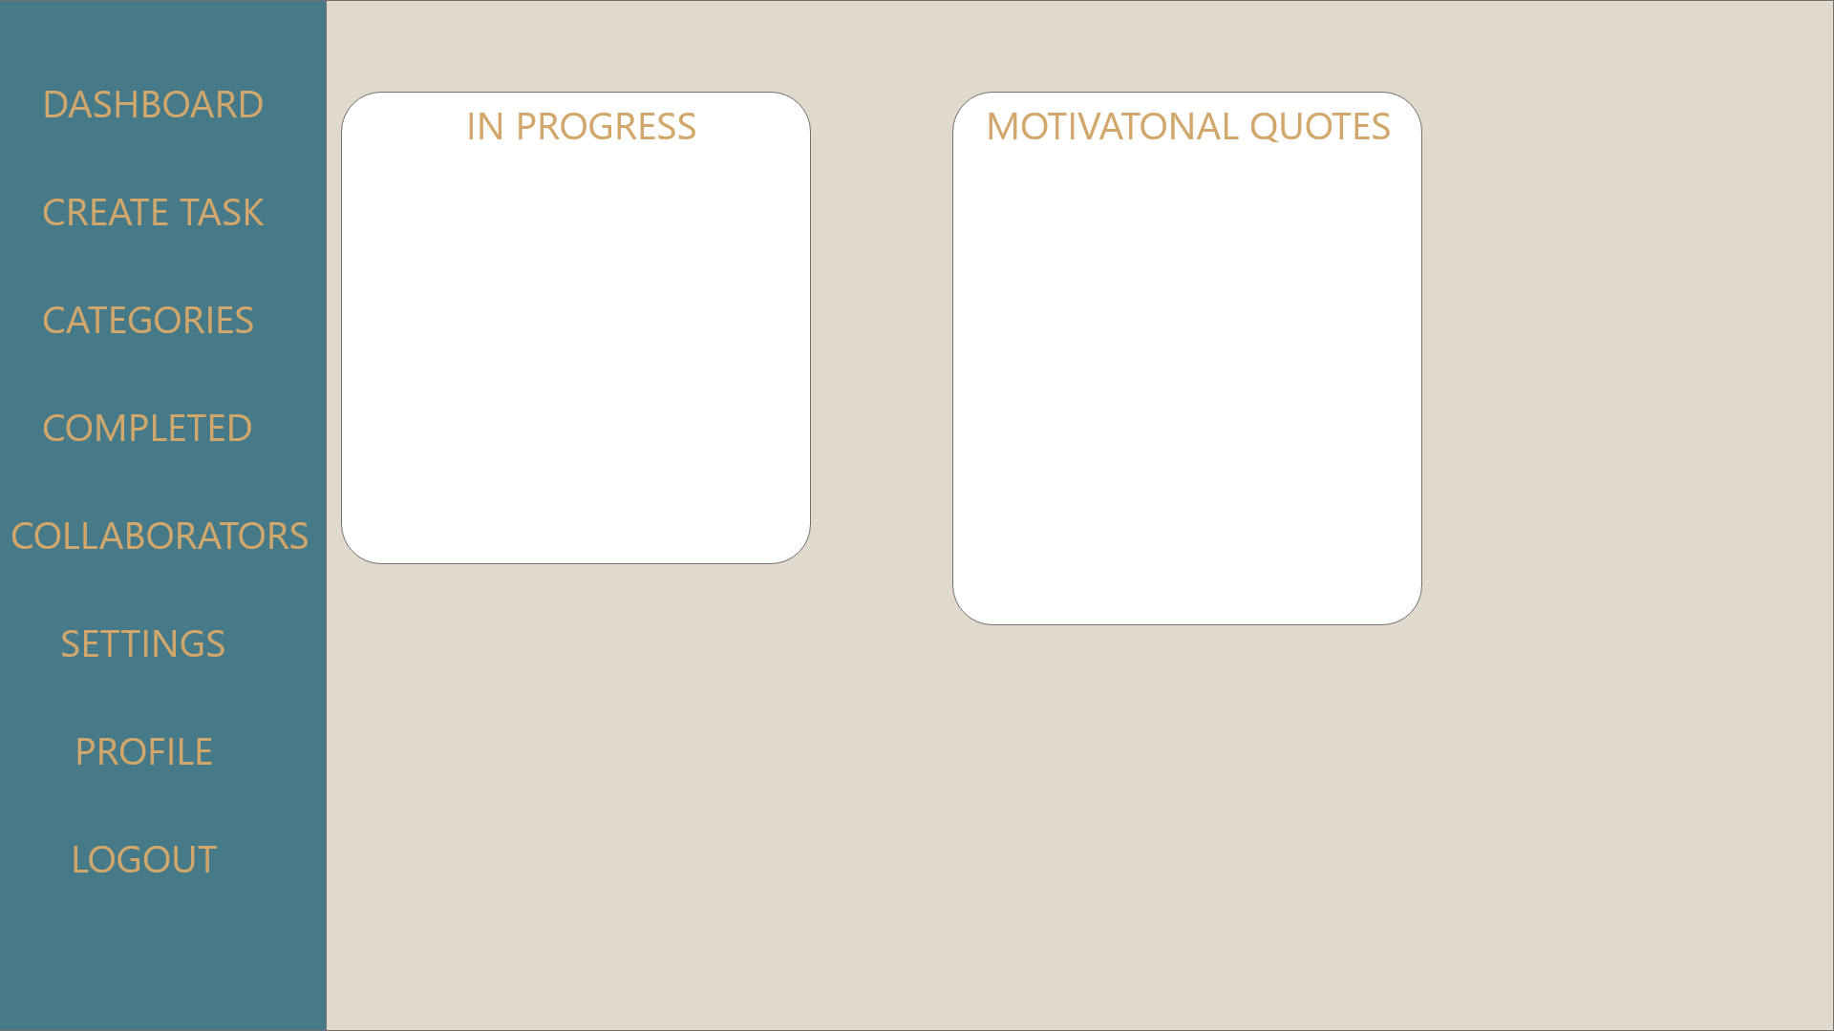

Check To-do Dashboard(homepage)

All designs are subject to change as development progresses.

**Conclusion:**

Our todo list app is a valuable tool for tertiary students. Its features address the challenges that students face in managing their tasks and can help reduce stress and anxiety. We believe that our app will be useful to students and will help them achieve their academic goals.